##### **18.1** Write a program to illustrate **Event Handling** for **Keyboard** Events

// importing awt libraries

import java.awt.*;

import java.awt.event.*;

public class AWTKeyboardEvent **extends** Frame **implements** KeyListener

{

Label l;

**AWTKeyboardEvent**()

{

*// creating the label*

l = new Label();

*// setting the location of the label in frame*

l.setBounds (20, 50, 100, 20);

*// creating the text area*

TextArea area = new TextArea();

*// setting the location of text area*

area.setBounds (20, 80, 300, 300);

*// adding the KeyListener to the text area*

area.addKeyListener(this);

*// adding the label and text area to the frame*

add(l);

add(area);

*// setting the size, layout and visibility of frame*

setSize (400, 400);

setLayout (null);

setVisible (true);

**addWindowListener**(new WindowAdapter()

{

public void **windowClosing**(WindowEvent we)

{

System.exit(0); // Close the application

}

});

}

*// overriding the keyPressed() method of KeyListener interface*

public void **keyPressed** (KeyEvent e)

{

l.setText ("Key Pressed");

int keyCode = e.getKeyCode();

System.out.println("Key Pressed: " + KeyEvent.getKeyText(keyCode));

}

*// overriding the keyReleased() method of KeyListener interface*

public void **keyReleased** (KeyEvent e)

{

l.setText ("Key Released");

int keyCode = e.getKeyCode();

System.out.println("Key Released: " + KeyEvent.getKeyText(keyCode));

}

*// overriding the keyTyped() method of KeyListener interface*

public void **keyTyped** (KeyEvent e)

{

l.setText ("Key Typed");

char keyChar = e.getKeyChar();

System.out.println("Key Typed: " + keyChar);

}

*// main method*

public static void **main**(String[] args)

{

new AWTKeyboardEvent();

}

}

**Output:**

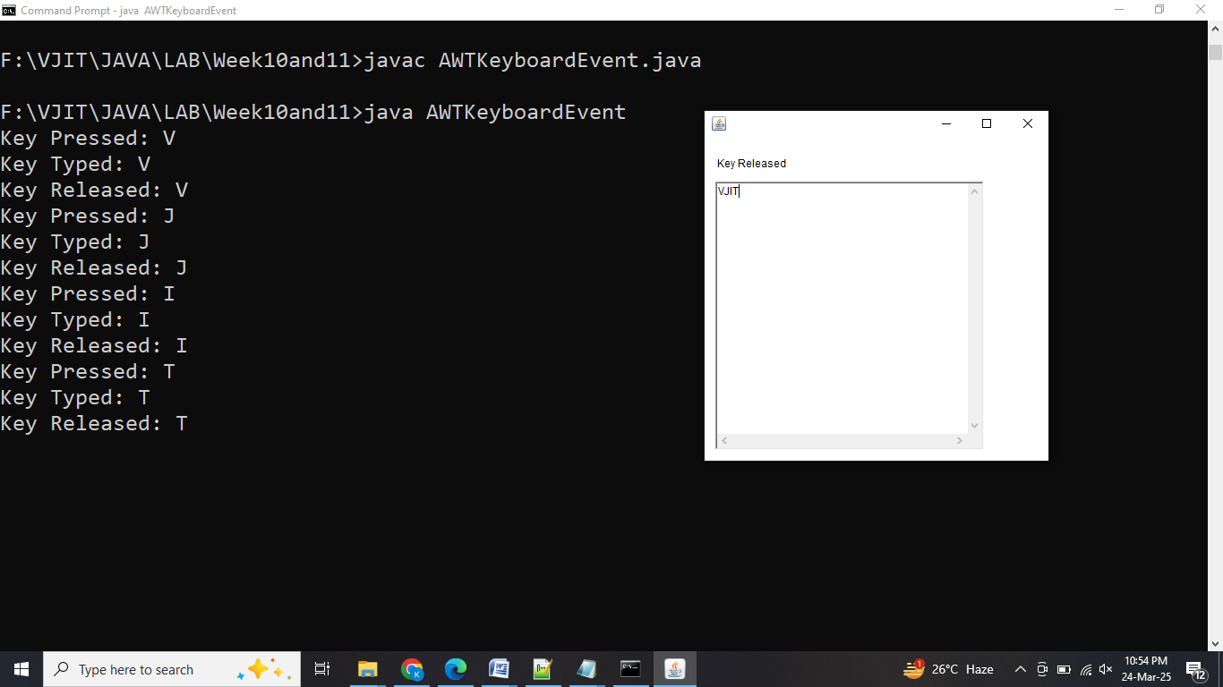

##### **18.2** Write a program to illustrate **Event Handling** for **Mouse** Events

import java.awt.*;

import java.awt.event.*;

public class AWTMouseEvent **extends** Frame **implements** MouseListener

{

Label l;

**AWTMouseEvent**()

{

addMouseListener(this);

l=new Label();

l.setBounds(20,50,100,20);

add(l);

setSize(300,300);

setLayout(null);

setVisible(true);

**addWindowListener**(new WindowAdapter()

{

public void **windowClosing**(WindowEvent we)

{

System.exit(0); // Close the application

}

});

}

public void **mouseEntered**(MouseEvent e)

{

l.setText("Mouse Entered");

System.out.println("Mouse Entered the component");

}

public void **mouseExited**(MouseEvent e)

{

l.setText("Mouse Exited");

System.out.println("Mouse Exited the component");

}

public void **mousePressed**(MouseEvent e)

{

l.setText("Mouse Pressed");

System.out.println("Mouse Pressed at: (" + e.getX() + ", " + e.getY() + ")"); }

public void **mouseReleased**(MouseEvent e)

{

l.setText("Mouse Released");

System.out.println("Mouse Released at: (" + e.getX() + ", " + e.getY() + ")");

}

public void **mouseClicked**(MouseEvent e)

{

l.setText("Mouse Clicked");

System.out.println("Mouse Clicked at: (" + e.getX() + ", " + e.getY() + ")"); }

public static void **main**(String[] args)

{

new AWTMouseEvent();

}

}

**Output:**

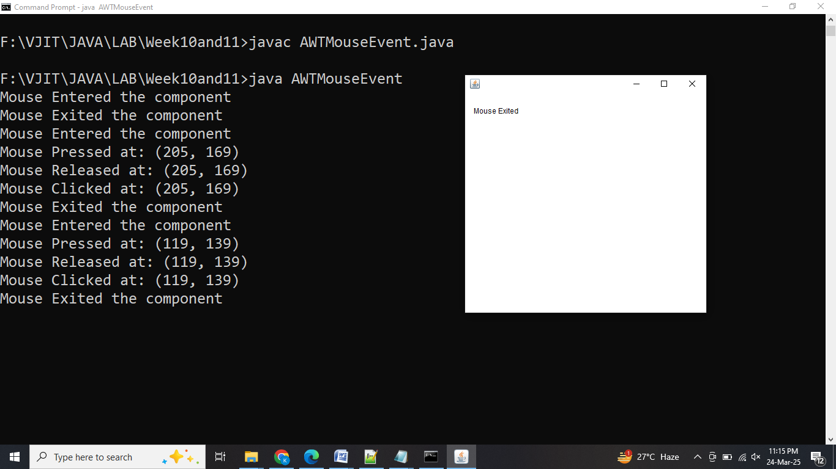

**19.** Write a program to illustrate **applet life cycle** and parameter passing.

import java.applet.Applet;

import java.awt.*;

import java.util.Date;

*/\**

*<applet code="AppletLifeCycle" width=300 height=200>*

*<param name="greeting" value="Welcome to Java Applet">*

*<param name="author" value="VJIT">*

*</applet>*

*\*/*

public class AppletLifeCycle **extends** Applet

{

*// Instance variables to store parameter values*

private String greetingMessage;

private String author;

*// Called when the applet is first loaded into memory*

@Override

public void **init**()

{

*// Retrieve parameters from the applet tag*

greetingMessage = getParameter("greeting"); // Get greeting message

author = getParameter("author"); // Get author name

if (greetingMessage == null)

{

greetingMessage = "Hello, this is a default greeting!";

}

if (author == null)

{

author = "Unknown Author";

}

System.out.println("Applet Initialized");

}

*// Called when the applet is started or brought to the foreground*

@Override

public void **start**()

{

System.out.println("Applet Started");

}

*// Called to display the applet on the screen*

@Override

public void **paint**(Graphics g)

{

// Display greeting message and author name on the applet

g.drawString(greetingMessage, 20, 50);

g.drawString("Author: " + author, 20, 70);

// Display current date and time

g.drawString("Current Date: " + new Date(), 20, 90);

}

*// Called when the applet is stopped (i.e., the user navigates away)*

@Override

public void **stop**()

{

System.out.println("Applet Stopped");

}

*// Called when the applet is destroyed*

@Override

public void **destroy**()

{

System.out.println("Applet Destroyed");

}

}

**Output:**

**In Browser**

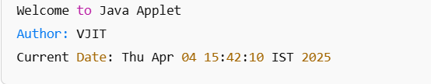

**In Command Prompt**

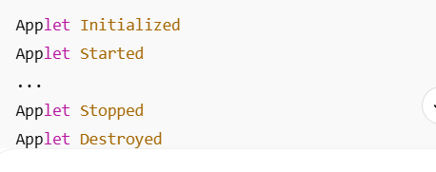

**20.** Write a program to develop a **Calculator** application using **AWT**

import java.awt.*;

import java.awt.event.*;

public class Calculator **extends** Frame **implements** ActionListener

{

*// Declare all components*

TextField display;

Button add, subtract, multiply, divide, equals, clear;

double num1, num2, result;

char operator;

*// Constructor to set up the GUI*

public **Calculator**()

{

*// Set title and layout*

setTitle("Calculator");

setSize(300, 400);

setLayout(new BorderLayout());

*// Create display (TextField)*

display = new TextField();

display.setEditable(false);

add(display, BorderLayout.NORTH);

*// Panel to hold number buttons*

Panel panel = new Panel();

panel.setLayout(new GridLayout(4, 4)); // 4 rows, 4 columns

*// Create Number buttons*

Button b0 = new Button("0");

Button b1 = new Button("1");

Button b2 = new Button("2");

Button b3 = new Button("3");

Button b4 = new Button("4");

Button b5 = new Button("5");

Button b6 = new Button("6");

Button b7 = new Button("7");

Button b8 = new Button("8");

Button b9 = new Button("9");

*// Create operator buttons*

add = new Button("+");

subtract = new Button("-");

multiply = new Button("*");

divide = new Button("/");

equals = new Button("=");

clear = new Button("C");

*// Add action listeners to the Number buttons*

b0.addActionListener(this);

b1.addActionListener(this);

b2.addActionListener(this);

b3.addActionListener(this);

b4.addActionListener(this);

b5.addActionListener(this);

b6.addActionListener(this);

b7.addActionListener(this);

b8.addActionListener(this);

b9.addActionListener(this);

*// Add action listeners to the operator buttons*

add.addActionListener(this);

subtract.addActionListener(this);

multiply.addActionListener(this);

divide.addActionListener(this);

equals.addActionListener(this);

clear.addActionListener(this);

*// Add operator buttons to the panel (in GridLayout)*

panel.add(b7);

panel.add(b8);

panel.add(b9);

panel.add(clear);

panel.add(b4);

panel.add(b5);

panel.add(b6);

panel.add(divide);

panel.add(b1);

panel.add(b2);

panel.add(b3);

panel.add(multiply);

panel.add(b0);

panel.add(add);

panel.add(subtract);

panel.add(equals);

*// Add the panel to the frame*

add(panel, BorderLayout.CENTER);

*// Window closing event*

**addWindowListener**(new WindowAdapter()

{

public void windowClosing(WindowEvent we)

{

System.exit(0);

}

});

// Set the frame visible

setVisible(true);

}

*// ActionListener method to handle button clicks*

public void **actionPerformed**(ActionEvent e)

{

String command = e.getActionCommand();

if ((command.charAt(0) >= '0' && command.charAt(0) <= '9'))

{

*// If a number is pressed, add it to the display*

display.setText(display.getText() + command);

}

else if (command.charAt(0) == 'C')

{

*// Clear the display when 'C' is pressed*

display.setText("");

}

else if (command.charAt(0) == '=')

{

*// When '=' is pressed, calculate the result*

num2 = Double.parseDouble(display.getText());

switch (operator)

{

case '+':

result = num1 + num2;

break;

case '-':

result = num1 - num2;

break;

case '*':

result = num1 * num2;

break;

case '/':

if (num2 != 0)

{

result = num1 / num2;

}

else

{

display.setText("Error");

return;

}

break;

}

display.setText(String.valueOf(result));

num1 = result; // Store result for further calculation

}

else

{

*// When an operator is pressed, store the number and operator*

if (!display.getText().isEmpty())

{

num1 = Double.parseDouble(display.getText());

operator = command.charAt(0);

display.setText("");

}

}

}

public static void **main**(String[] args)

{

*// Create an instance of the Calculator class*

new Calculator();

}

}

**Output:**

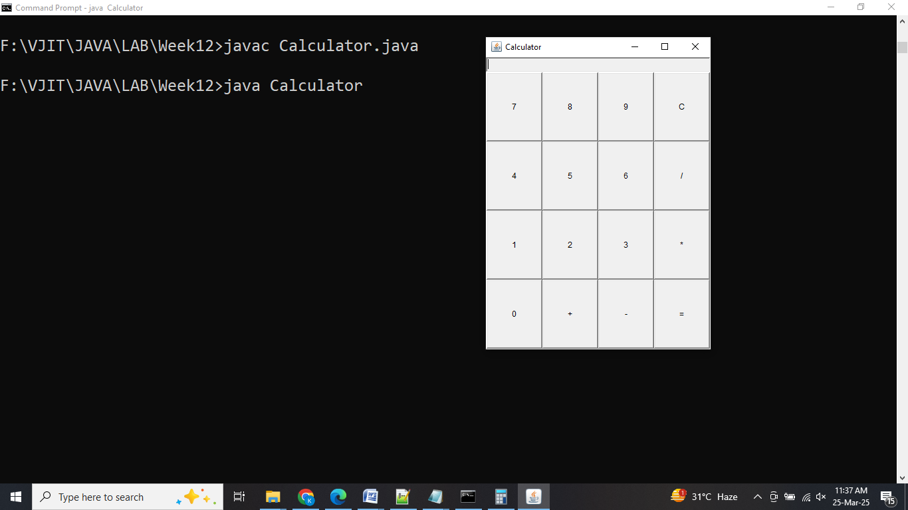

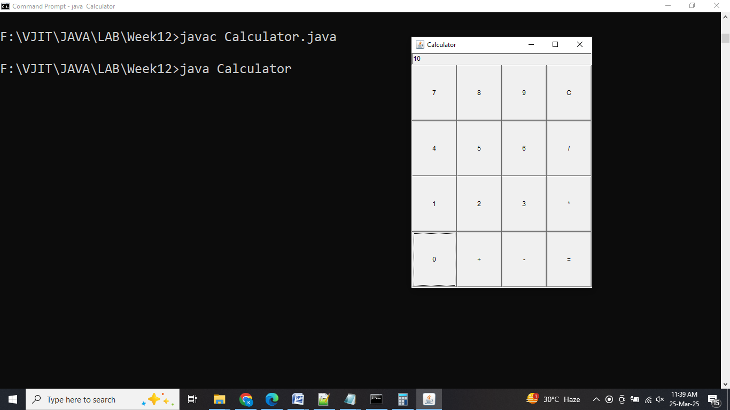 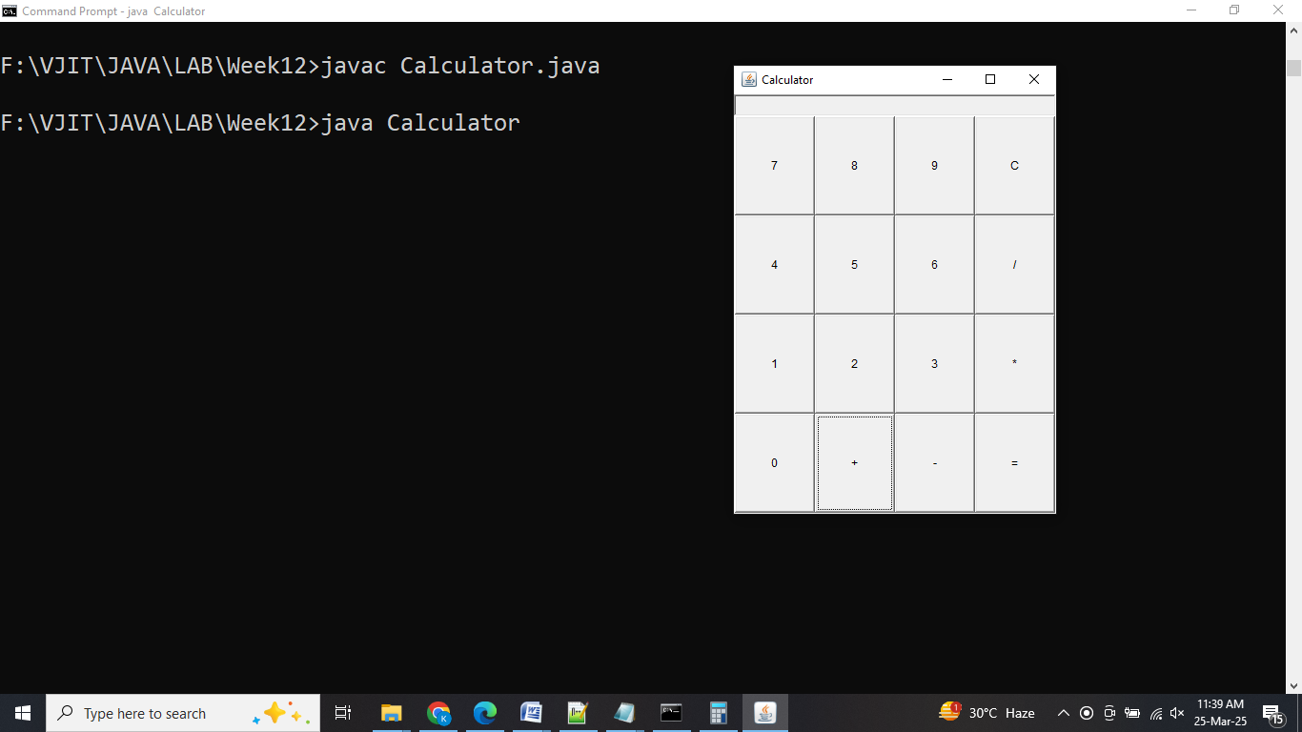

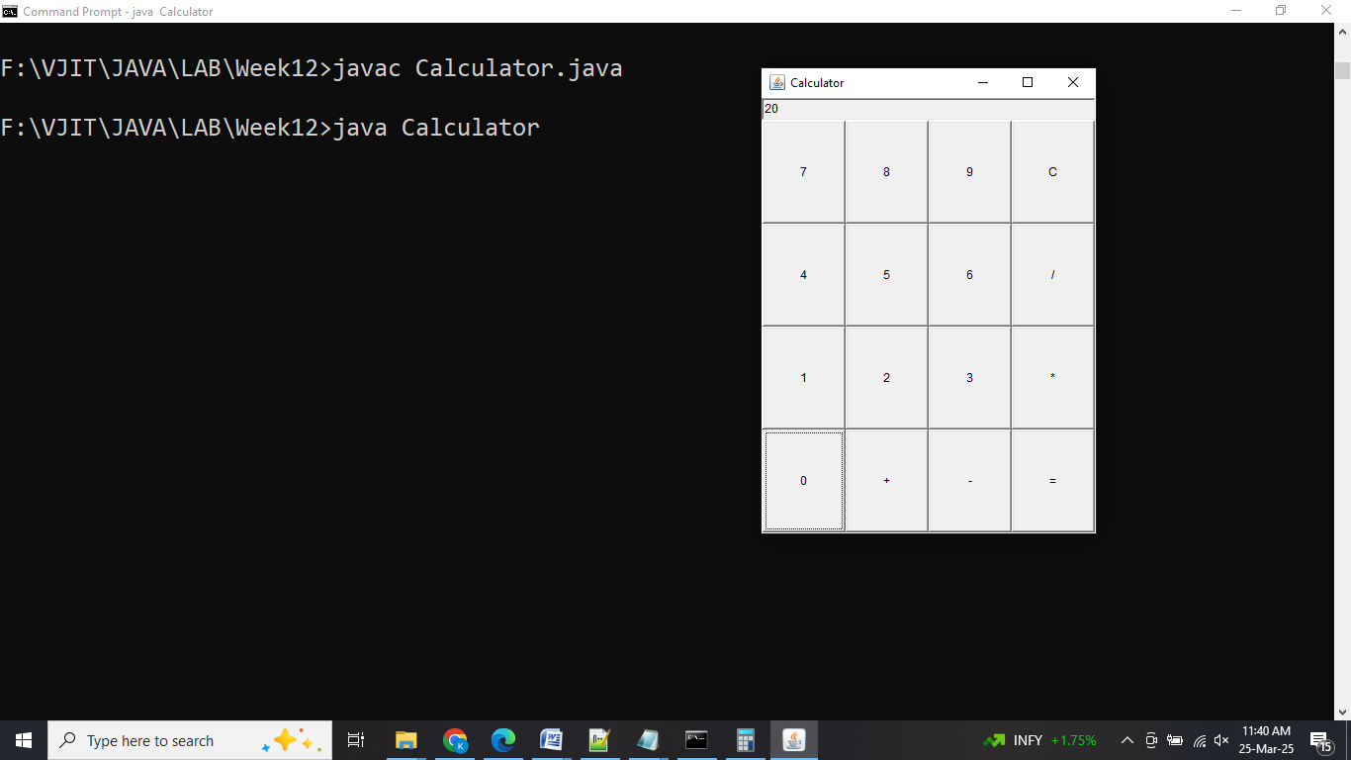 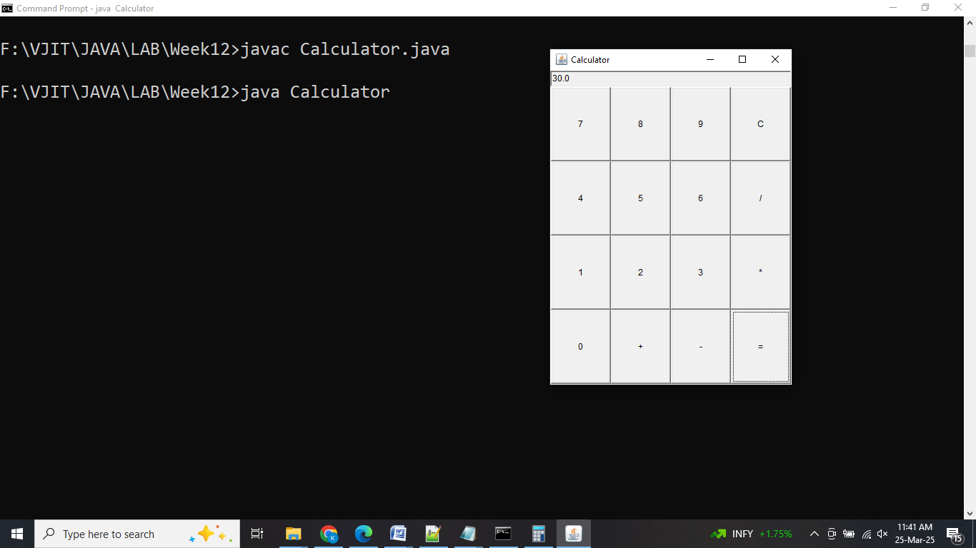

**21.1** Java Program to **CREATE** Database Table in MySql Server

*// This code is for establishing connection with MySQL database and retrieving data*

*// from database through JDBC*

*/\**

*\*1. import --->java.sql*

*\*2. load and register the driver ---> com.jdbc.*

*\*3. create connection*

*\*4. create a statement*

*\*5. execute the query*

*\*6. process the results*

*\*7. close*

*\*/*

import java.io.*;

import java.sql.*;

class **create**

{

public static void **main**(String[] args) throws ClassNotFoundException,SQLException

{

String url= "jdbc:mysql://localhost:3306/vjit"; // Database details

String username = "root"; // MySQL credentials

String password = "vjit";

Class.forName("com.mysql.cj.jdbc.Driver"); // Driver name

Connection con = DriverManager.getConnection(url, username, password);

System.out.println("Connection Established successfully");

Statement st = con.createStatement();

String sql = "CREATE TABLE STUDENTS(Roll_No INTEGER NOT NULL,First_Name VARCHAR(255),Last_Name VARCHAR(255),Age INTEGER,PRIMARY KEY ( Roll_No ))";

st.execute(sql);

System.out.println("Created table in given database...");

st.close(); // close statement

con.close(); // close connection

System.out.println("Connection Closed....");

}

}

**Output:**

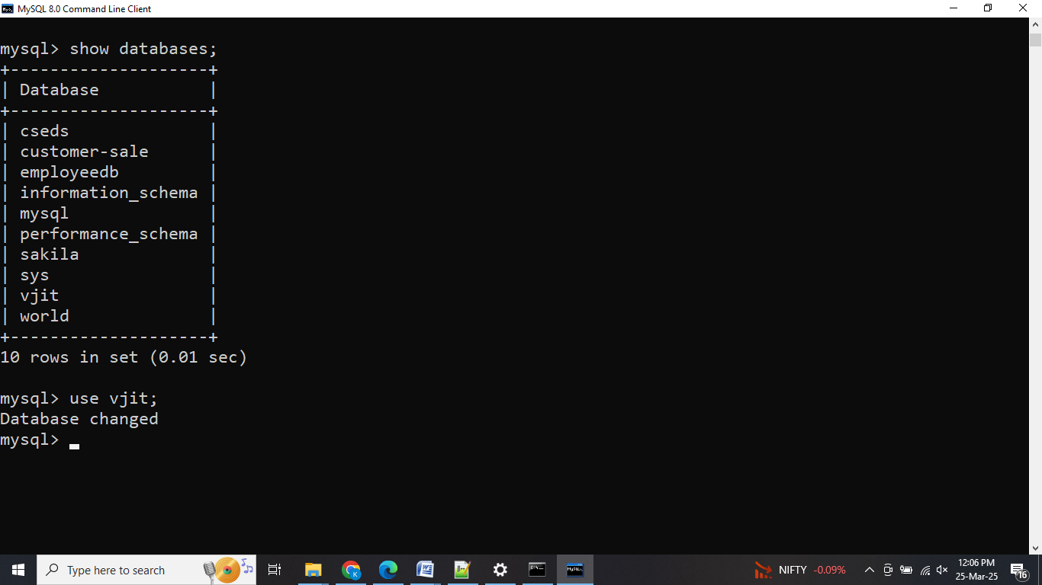

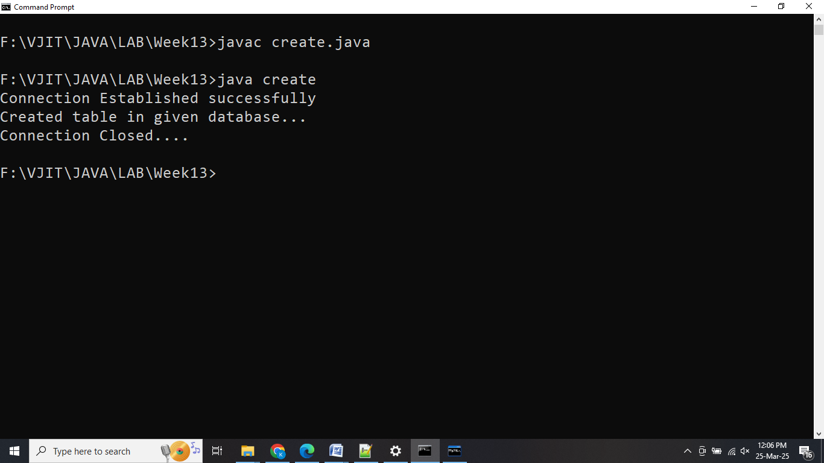

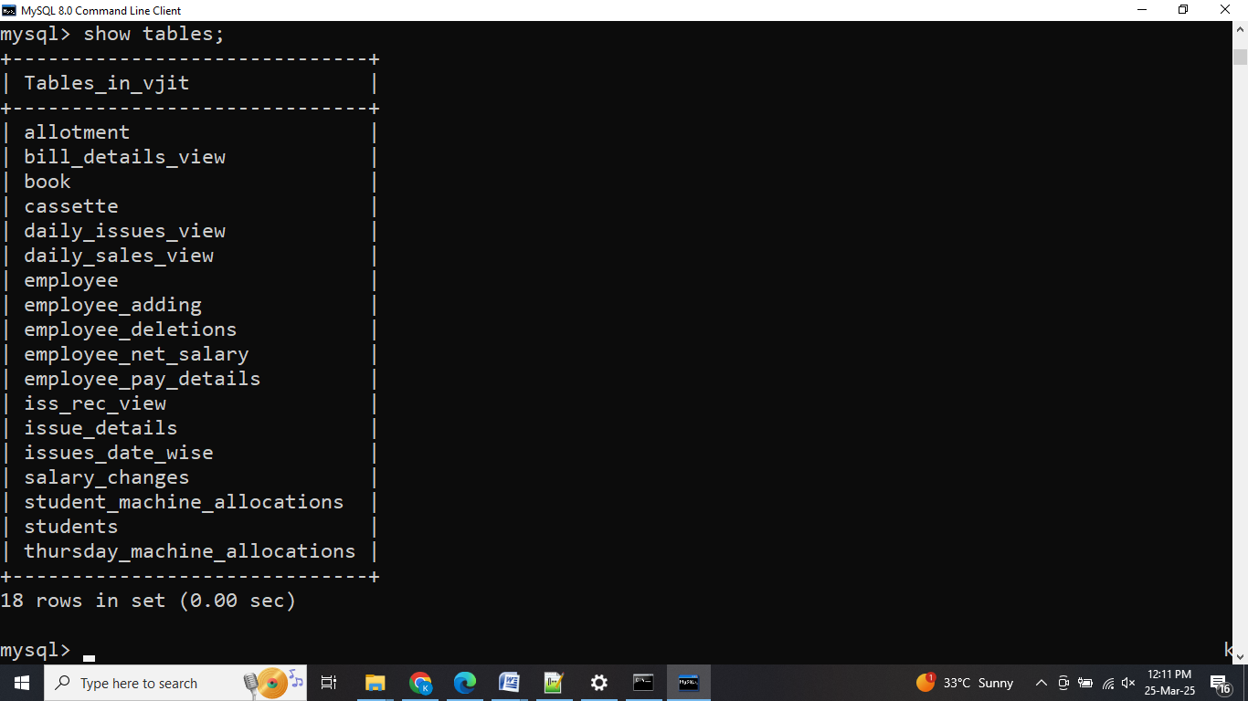

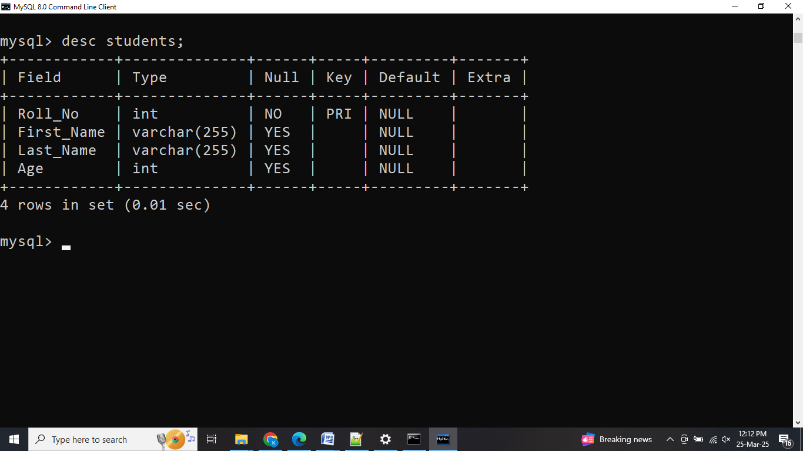

**21.2** Java Program to **INSERT** Record into Database Table in MySql Server

import java.sql.*;

class **StudentInsertionApplication**

{

public static void **main**(String[] args) throws ClassNotFoundException,SQLException

{

String url= "jdbc:mysql://localhost:3306/vjit"; *// Database details*

String username = "root"; // MySQL credentials

String password = "vjit";

Class.forName("com.mysql.cj.jdbc.Driver"); *// Driver name*

Connection con = DriverManager.getConnection(url, username, password);

System.out.println("Connection Established successfully");

Statement st = con.createStatement();

int c = st.executeUpdate("insert into students values(6703,'Rahul','HYD',20)");

System.out.println(c + "\t Student Record inserted successfully");

st.close();

con.close();

}

}

**Output:**

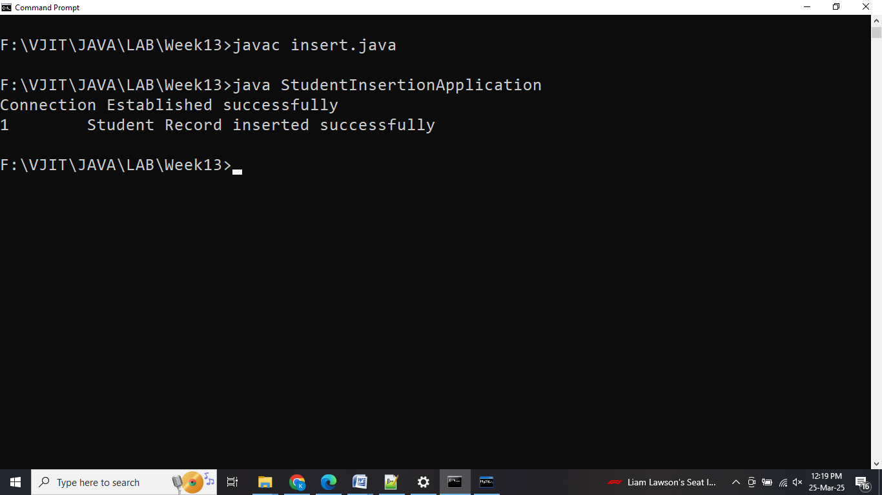

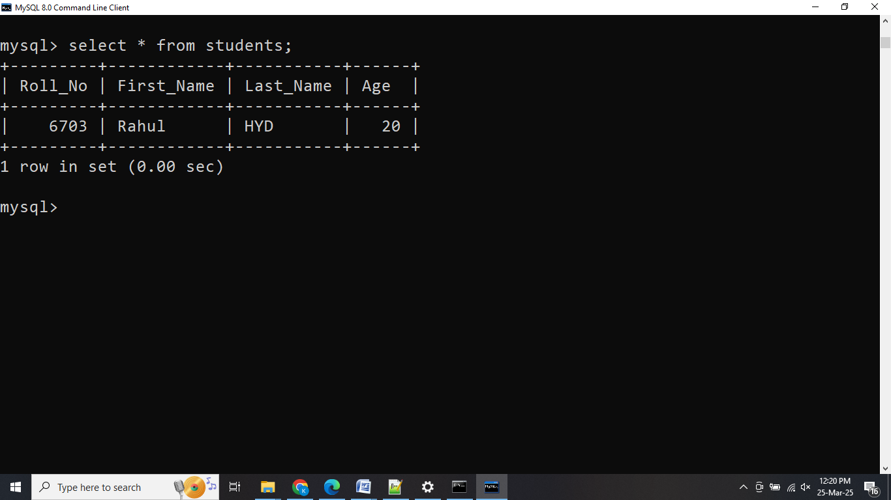

**21.3** Java Program to **UPDATE** Record into Database Table in MySql Server

import java.sql.*;

class **UpdateStudentApplication**

{

public static void **main** (String[]args) throws ClassNotFoundException, SQLException

{

String url= "jdbc:mysql://localhost:3306/vjit"; *// Database details*

String username = "root"; // MySQL credentials

String password = "vjit";

Class.forName("com.mysql.cj.jdbc.Driver"); *// Driver name*

Connection con = DriverManager.getConnection(url, username, password);

System.out.println("Connection Established successfully");

Statement st = con.createStatement();

int rows = st.executeUpdate("update students set First_Name = 'Rahul Dravid' where Roll_No=6703");

System.out.println(rows + " row modified");

st.close();

con.close();

}

}

**Output:**

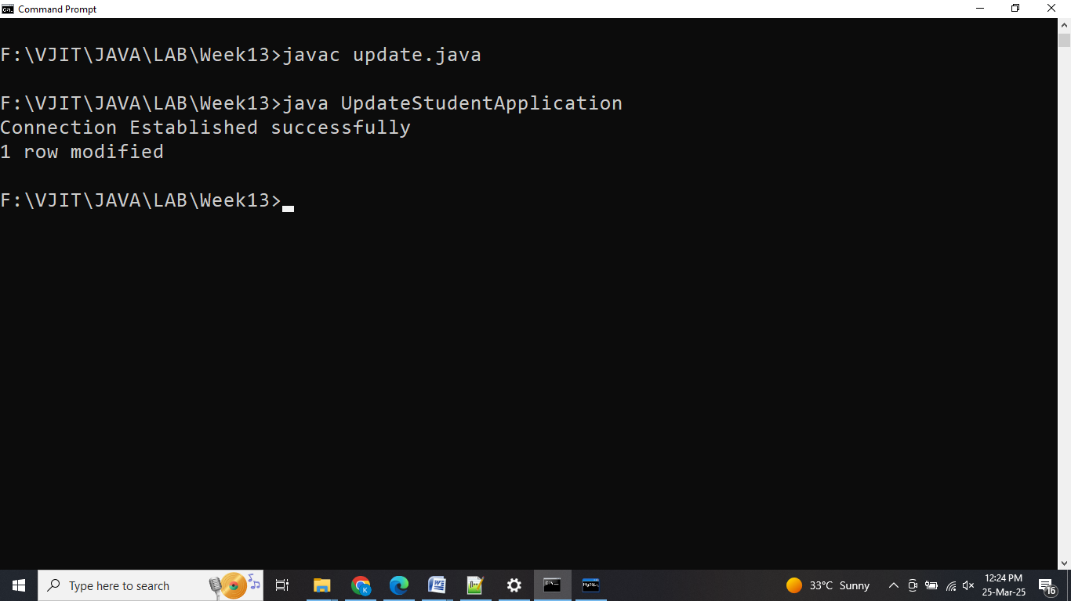

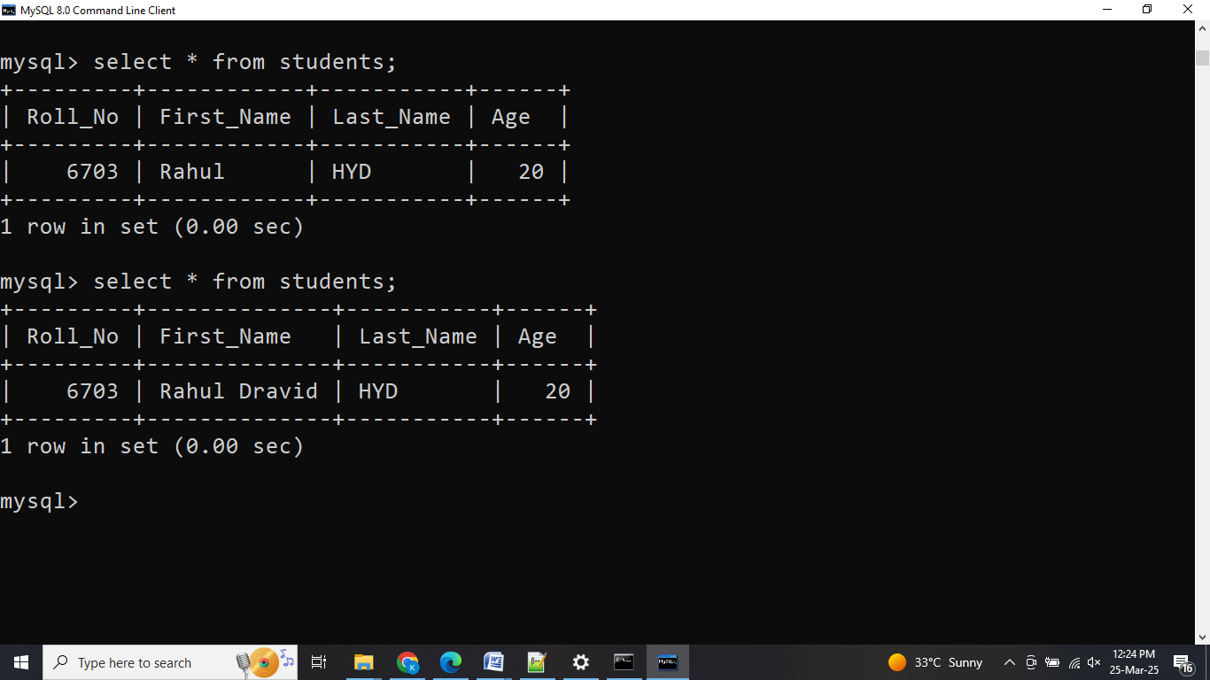

**21.4** Java Program to **DELETE** Record from Database Table in MySql Server

import java.sql.*;

import java.util.*;

class **StudentDeleteApplication**

{

public static void **main** (String[]args) throws ClassNotFoundException, SQLException

{

String url= "jdbc:mysql://localhost:3306/vjit"; *// Database details*

String username = "root"; *// MySQL credentials*

String password = "vjit";

Class.forName("com.mysql.cj.jdbc.Driver"); *// Driver name*

Connection con = DriverManager.getConnection(url, username, password);

System.out.println("Connection Established successfully");

Statement st = con.createStatement();

Scanner sc = new Scanner(System.in);

System.out.println("ENTER STUDENT NUMBER");

int rno = sc.nextInt();

int c = st.executeUpdate("delete from students where Roll_No =" + rno);

if (c == 0)

System.out.println("Student data does not exist");

else

System.out.println("Student data deleted successfully");

st.close();

con.close();

}

}

**Output:**

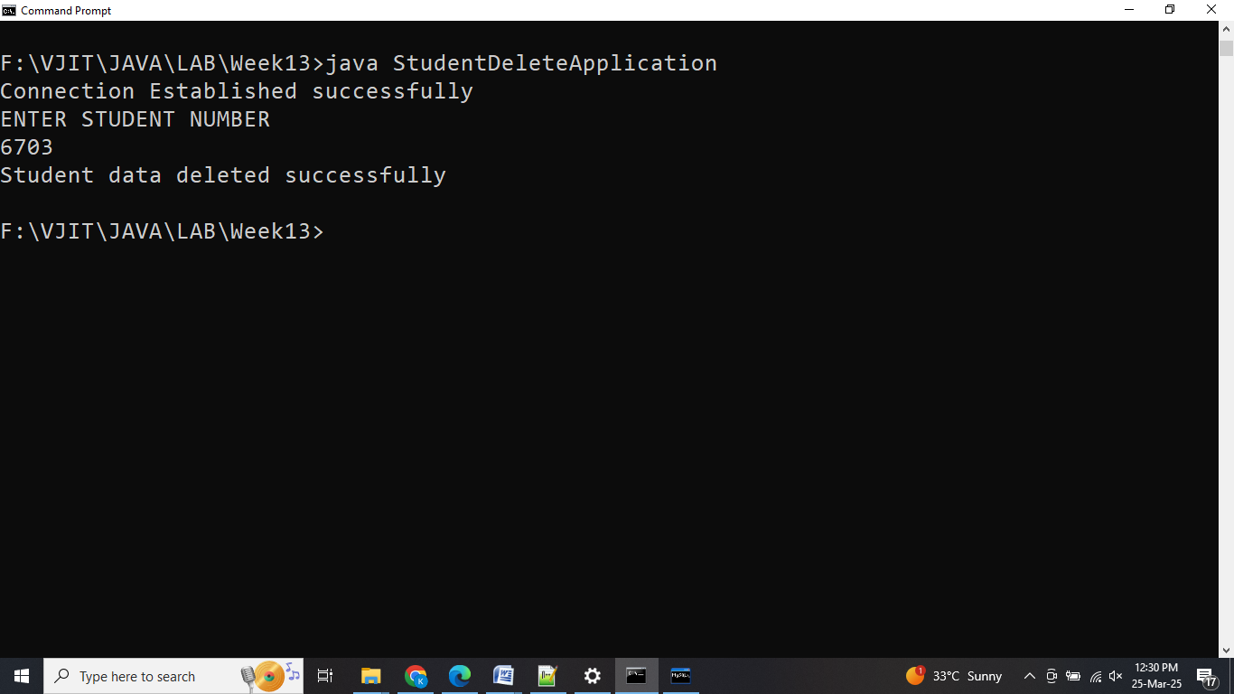

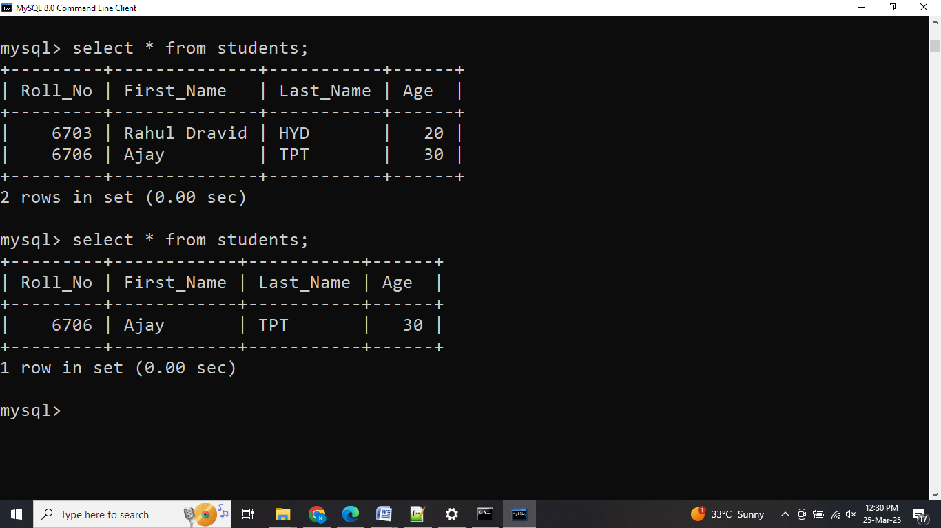

**21.5** Java Program to **SELECT** Records from Database Table in MySql Server

import java.sql.*;

import java.util.*;

class **StudentsDetails**

{

public static void **main** (String[]args) throws ClassNotFoundException, SQLException

{

String url= "jdbc:mysql://localhost:3306/vjit"; *// Database details*

String username = "root"; *// MySQL credentials*

String password = "vjit";

Class.forName("com.mysql.cj.jdbc.Driver"); *// Driver name*

Connection con = DriverManager.getConnection(url, username, password);

System.out.println("Connection Established successfully");

Statement st = con.createStatement();

System.out.println("\n\nStudent Details: ");

System.out.println("----------------------");

ResultSet rs = st.executeQuery("select * from students");

while(rs.next())

{

System.out.println("Roll No: " + rs.getInt(1));

System.out.println("First Name: " + rs.getString(2));

System.out.println("Last Name : " + rs.getString(3));

System.out.println("----------------------");

}

rs.close();

st.close();

con.close();

}

}

**Output:**

